006BC2744 - Day 12 (31 July 2026)

Task 1: Why is there a need for DBMS?

A DBMS (Database Management System) is needed to efficiently store, organize, retrieve, and manage large amounts of data. It also provides data security, consistency, concurrency control, and backup/recovery.

Task 2: Why not traditional DBMS?

Traditional DBMS can become less suitable when applications need very large-scale data, high scalability, flexible data models, or distributed processing. Modern systems such as NoSQL databases are often preferred for these requirements because they can scale horizontally and handle unstructured or rapidly changing data.

Task 3: Explain the concept of data independence in DBMS.

Data independence in DBMS means the ability to change the database structure at one level without affecting the next higher level. It allows changes to storage or schema without requiring changes to application programs.
There are two types: Physical data independence and Logical data independence.

Task 4: What are the different types of database models (hierarchical, network, relational, object-oriented)? Explain with examples

- Hierarchical: Organizes data in a tree structure with parent-child relationships. Example: Company → Department → Employee.
- Network: Organizes data as a graph, allowing many-to-many relationships. Example: Students ↔ Courses.
- Relational: Stores data in tables (rows and columns) connected using keys. Example: MySQL with Customer and Account tables.
- Object-Oriented: Stores data as objects containing attributes and methods. Example: a Customer object containing customer details and operations.

Task 5: Describe concurrency control in DBMS. Why is it important?

Concurrency control in DBMS manages multiple transactions accessing the database at the same time. It is important to prevent problems like lost updates, dirty reads, and inconsistent data, while maintaining data consistency.

Task 6: What are indexes in DBMS? How do they improve query performance?

Indexes are special data structures that help the DBMS find records faster without scanning the entire table. They improve query performance, especially for columns frequently used in WHERE, JOIN, and ORDER BY clauses.

Task 7: Explain deadlock in DBMS. What are the strategies for deadlock prevention and detection?

A deadlock occurs when two or more transactions wait indefinitely for each other to release locked resources.
Prevention uses techniques like resource ordering and timeout, while detection uses a wait-for graph to identify cycles and then rolls back one transaction.

Task 8: What do you understand about the Relational model?

The Relational Model represents data as tables (relations) consisting of rows (records) and columns (attributes). Tables are connected using keys, such as primary keys and foreign keys, to maintain relationships and data integrity.

Task 9: Specify key terms that you encounter in RDBMS. Give brief explanation

Common RDBMS key terms include:

- Table (Relation): Stores data in rows and columns.
- Row (Tuple): Represents a single record in a table.
- Column (Attribute): Represents a property/field of the data.
- Primary Key: Uniquely identifies each row.
- Foreign Key: Links one table to another.
- Candidate Key: A column or set of columns that can uniquely identify a row.
- Constraint: Rules that maintain data accuracy and integrity, such as NOT NULL, UNIQUE, and CHECK.

Task 10: What are different types of keys in RDBMS?
Explain using diagrams ..

Types of Keys in RDBMS

- Primary Key: Uniquely identifies each record in a table and cannot contain NULL values.
- Foreign Key: Links two tables by referencing the primary key of another table.
- Candidate Key: A column or set of columns that can uniquely identify a record and can become the primary key.
- Alternate Key: A candidate key that is not selected as the primary key.
- Composite Key: A key made up of two or more columns used together to uniquely identify a record.
- Super Key: Any combination of columns that can uniquely identify a record, including candidate keys.

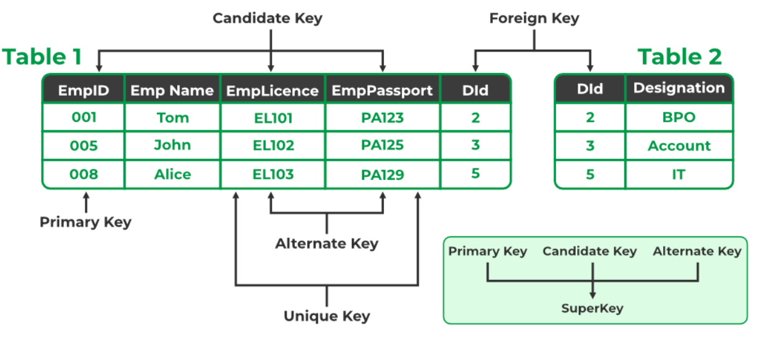

Task 11: As you know diff keys in RDBMS what is the difference between primary key, foreign key, and unique key?

- Primary Key: Uniquely identifies each row; cannot contain NULL values, and a table normally has one primary key.
- Foreign Key: References a key (usually the primary key) in another table to establish a relationship between tables.
- Unique Key: Ensures all values in a column (or column combination) are unique; unlike a primary key, it can generally allow NULL depending on the database.

Task 12: How does transaction management work in DBMS? Give an example of commit and rollback

Transaction management ensures a group of database operations is completed successfully as one unit. If everything succeeds, use COMMIT; if an error occurs, use ROLLBACK to undo the changes.

UPDATE accounts SET balance = balance - 500 WHERE id = 1;
UPDATE accounts SET balance = balance + 500 WHERE id = 2;
COMMIT; -- Save both changes
-- ROLLBACK; -- Undo changes if an error occurs

Task 13: What is normalization? Why is it necessary in database design?

Normalization is the process of organizing data into related tables to reduce data redundancy and inconsistency.
It is necessary to improve data integrity, avoid duplicate data, and make database maintenance easier.

Task 14: What do you understand by 1nf? Explain with an example

1NF (First Normal Form) means each column must contain atomic (single) values, and there should be no repeating groups or multiple values in one cell.
Example: Instead of Phone = 9876, 8765, store each phone number in a separate row or related table.

Task 15: What do you understand about 2NF? Explain with an example.

2NF (Second Normal Form) means the table must be in 1NF and every non-key column must depend on the entire primary key, not just part of it.
Example: If (StudentID, CourseID) is the primary key, StudentName depends only on StudentID, so it should be moved to a separate Student table.

Task 16: What do you understand by 3 nf ? Explain with an example

3NF (Third Normal Form) means the table must be in 2NF and no non-key column should depend on another non-key column (no transitive dependency).
Example: If StudentID → DepartmentID → DepartmentName, move DepartmentName to a separate Department table.

Task 17: What do you understand by joins? Explain all joins with examples

JOIN is used to combine rows from two or more tables using a related column.

Using Customer and City tables:

Customer City
id, name, city_id city_id, city_name
Types of JOINs

INNER JOIN: Returns only matching records from both tables.

SELECT c.name, ci.city_name
FROM Customer c JOIN City ci ON c.city_id = ci.city_id;

LEFT JOIN: Returns all records from the left table and matching records from the right.

SELECT c.name, ci.city_name
FROM Customer c LEFT JOIN City ci ON c.city_id = ci.city_id;

RIGHT JOIN: Returns all records from the right table and matching records from the left.

SELECT c.name, ci.city_name
FROM Customer c RIGHT JOIN City ci ON c.city_id = ci.city_id;
FULL OUTER JOIN: Returns all records from both tables, matching where possible. (MySQL doesn't directly support it.)

CROSS JOIN: Returns every possible combination of rows from both tables.

SELECT * FROM Customer CROSS JOIN City;

SELF JOIN: A table is joined with itself, commonly used for employee-manager relationships.

SELECT e.name, m.name AS manager
FROM Employee e JOIN Employee m ON e.manager_id = m.id;

Easy to remember:
INNER = matching | LEFT = all left | RIGHT = all right | FULL = all | CROSS = combinations | SELF = same table

